Brenden Heitz
Project 2 (Overview): Data Analytics and Visualization
Data Analytics Career Simulation 2
Dashboard Screenshots

Screenshots of key layouts and dashboard overall below:

Total sales overtime:
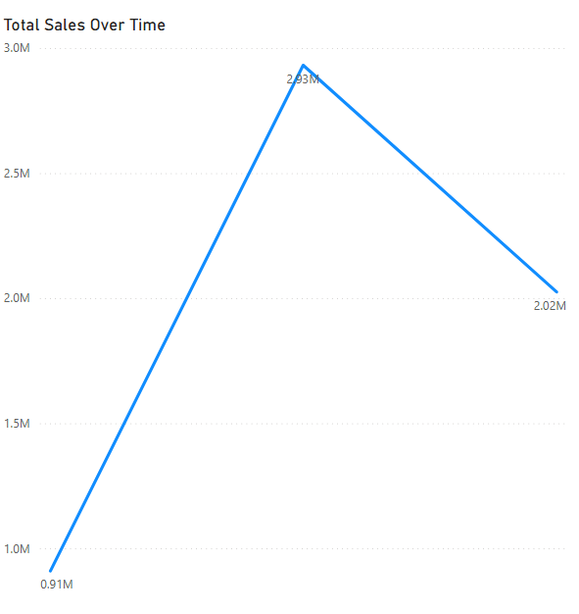

Average Order Value and Sales by Region:

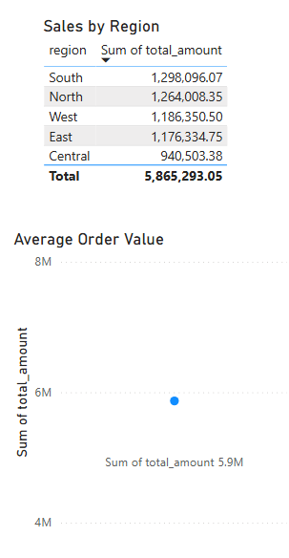

Sales by Category:

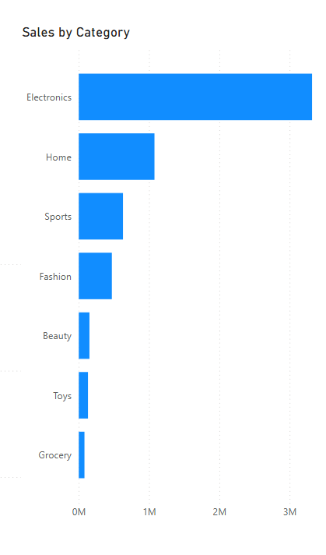
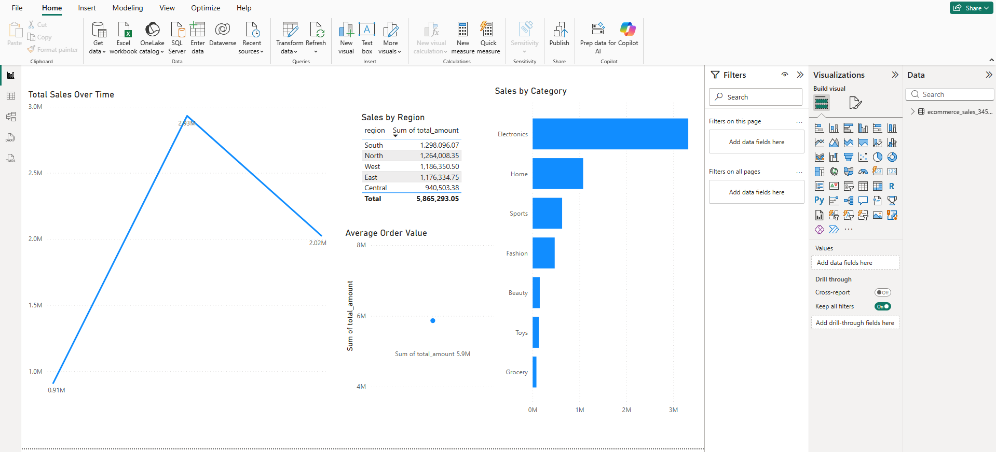
Overview of the entire dashboard with overall layout:

